WELCOME TO THE RADIOECOLOGICAL SOFTWARE PACKAGE MANUAL.

This manual is divided into two parts. First comes the installation process, second the instruction manual on how to use the program. If you have any further questions or doubts, e-mail me at emilianoc@hotmail.com.

System requirements

Hardware: 30 or more Mb of RAM memory.
Free space in disk for Mb.
A Pentium II Processor.
Software: Windows 98 O.S. or superior.
Origin 6.0
InterBase data base administrator

Installation Process

1.Install InterBase as you regularly would.

2. When asked if you want to create ODBC Data sources, click Skip. The Set Up is now complete.

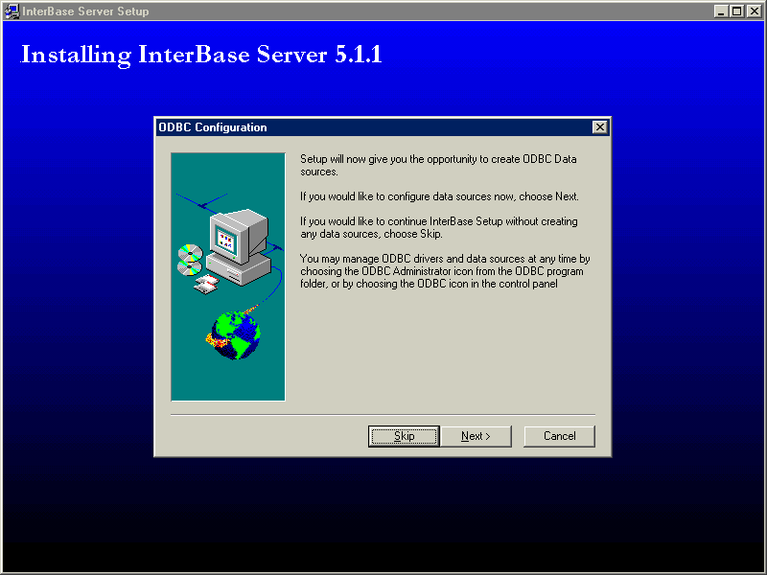

3. Next go to Start / Programs / InterBase 5.0 and click on InterBase Guardian. This will activate the data base server.

4. The InterBase icon should now be on the menu bar.

5. Install Origin 6.0 if you would like to view your output with it.

6. Download rsp.zip from www.unsl.edu.ar/~apatunsl/rsp.zip.

7. Unzip the file.

8. Open the Radioecological Software Package folder. Double click on SETUP.EXE.

9. When asked if you want to restart your computer now CLICK NO, I WILL START MY COMPUTER LATER. THIS IS VERY IMPORTANT. If you don´t, you will have to re-install Windows.
Then click Finish.

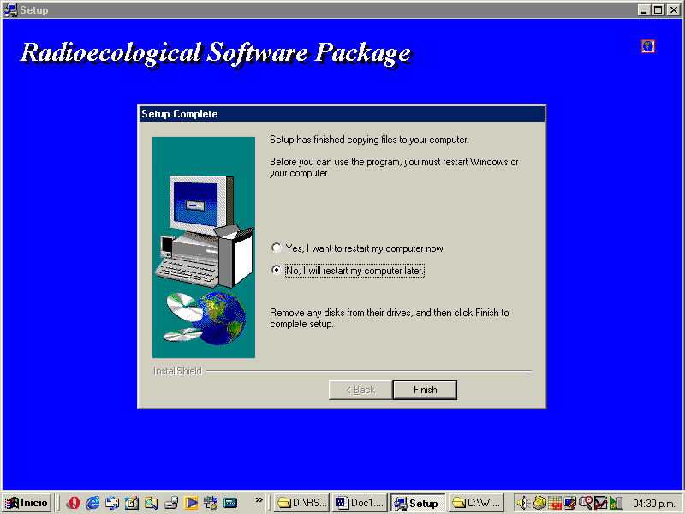

10. The Set Up is now complete. You can run the Radioecological Software Package.

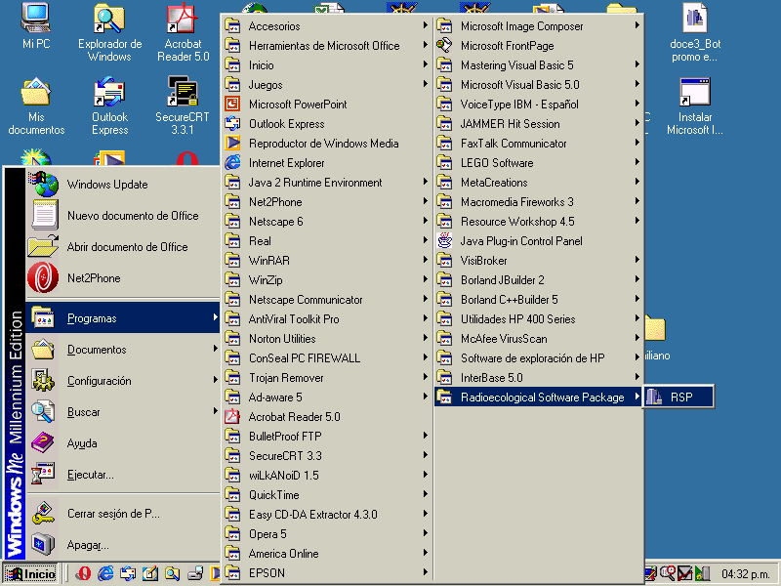

Part 2: Using the Radiocological Software Package

The program has the following structure:
It has three modules, each of which consist of:

1) a window for entering data and running the simulation .

2) a window for viewing the results as tables and/or graphics.

3) a window for opening and deleting files.

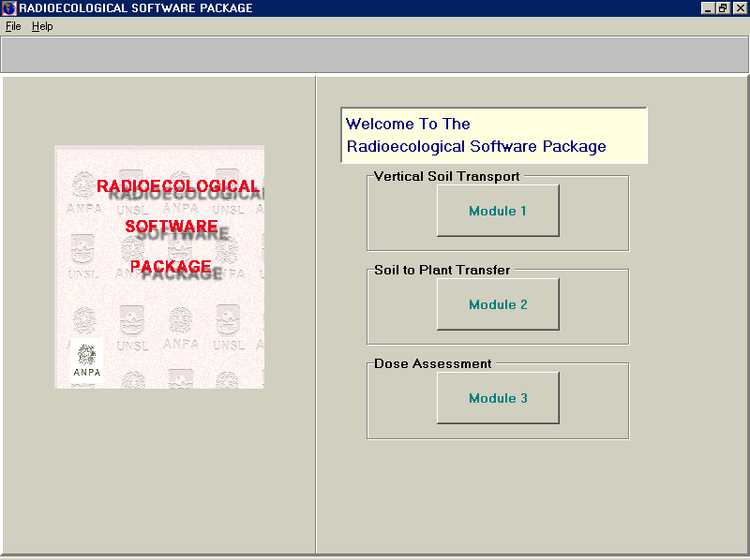

Module 1: Vertical Soil Transport.

(Espcificacion sobre el módulo)

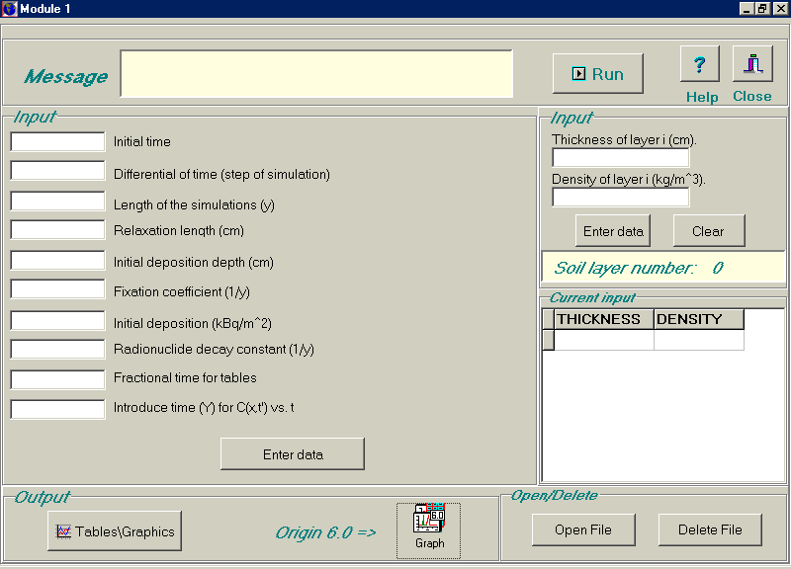

To run a new a new simulation, enter the data on the blank fields. Then click the enter data button.

If you want to clear all fields, click on Clear.

Where requested to enter thickness and density of layer i, you are allowed to enter data of up to 10 layers of soil.
After each layer, click the enter data button. You will be able to view your input on the lower part of your screen.

To view the results, click the run button.
A window will pop up asking you to wait until the simulation has ended running.

You can view the results either by clicking the Tables and
graphs button or by running Origin 6.0.

Opening and deleting files

To open an existing file, click the Open file button. Select the file from the list and click open.
Then click on the table or graph you want to view as you would with a new simulation.
To view the data stored click view input.

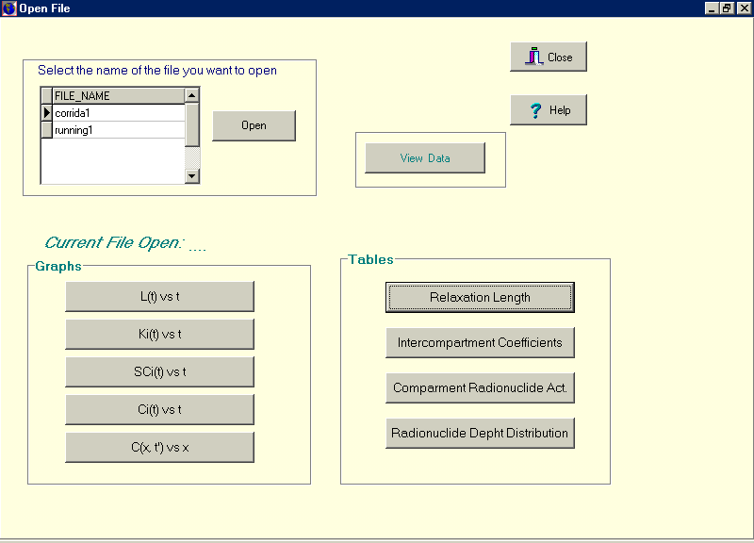

To delete a file, click on Delete file and pick the name of the file you wish to delete from the list on your screen.
Then click Delete.

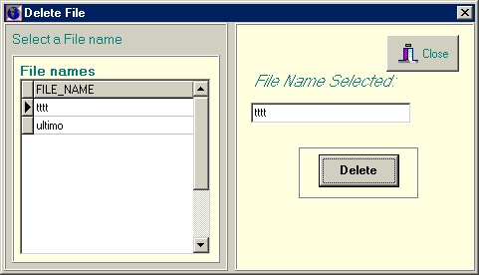

Viewing results.

Viewing tables and graphics with the Tables/Graph option

To view a table or a graph click on its button. Click Close to close or click on another table or graph and the former will be automatically replaced.

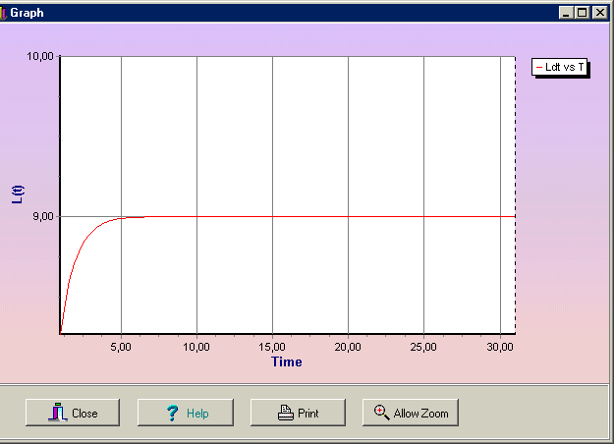

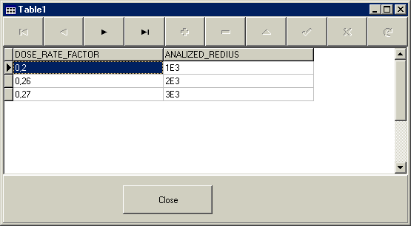

You can zoom a chart area by holding the left mouse button and dragging the mouse toward down/right. You'll see a rectangle around the selected area.
Release the left mouse button to Zoom. You can continue
zooming again and again.
To RESTORE (or UNDO) the zoom, drag a rectangle in the
opposite direction (up/left).

To displace the graph, hold the right mouse button and move
mouse.

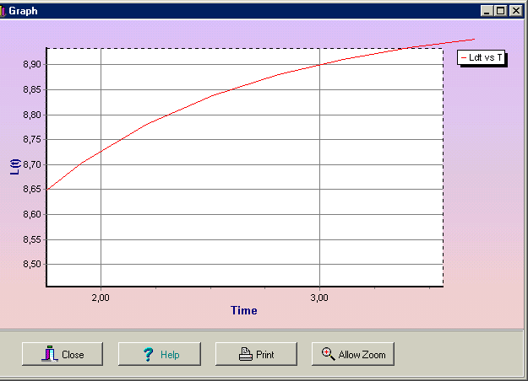

Saving results.

To save the results click Save. A window will pop up asking you to name the file, then click OK (do not click Enter).
If you exit without saving , the results will be stored until you run a new simulation.

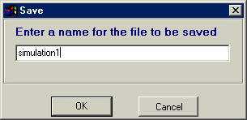

Viewing tables and graphics with origin 6.0

If you have chosen to view the output with Origin 6.0, double click on the Origin 6.0 icon and retrieve files with ASCII format from the following address:
C:\RADIOECOLOGICAL SOFTWARE PACKAGE, select File | Import | ASCII form its main menu and then choose the file you want to open.

Module 2: Soil to plant transfer.

(Especificacion)

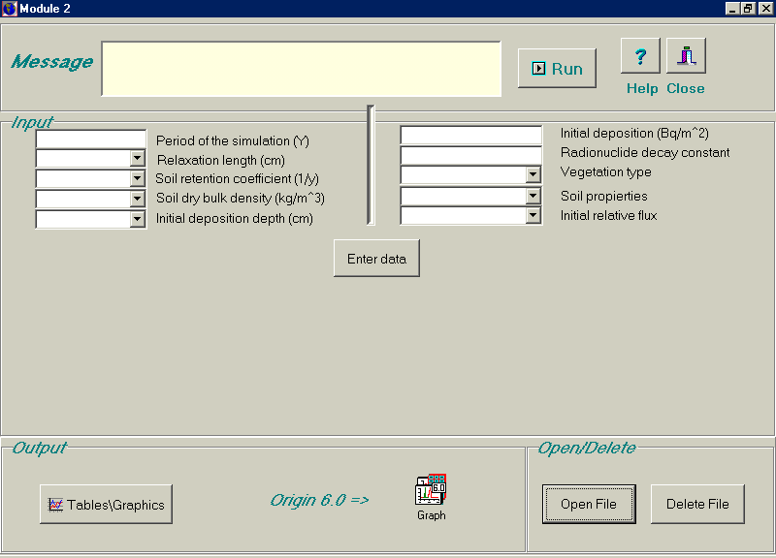

To run a new a new simulation, enter the data on the blank fields or pick a value from the menu.
Then click the enter data button.
To enter a value different from the ones on the list, simply click on the filed and then type it. If it is a real value,
separate the integer part from the decimal part by a colon (,) instead of by a period (.). If you don´t, a window will appear giving an error message.

To view tables and graphics or open or delete files, follow the same procedure as in Module1.

Module 3: Dose Assesment

(Especificación)

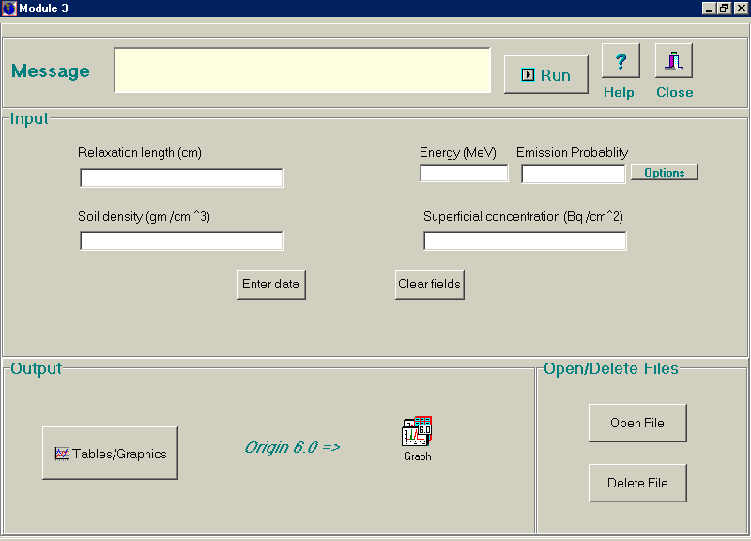

To run a new a new simulation, enter the data on the
blank fields or pick a value from the menu.
On the Energy Emission probability field, to enter a value different from the ones on the list, click on other and then simply type the value on the field.
If it is a real value, separate the integer part from the decimal part by a colon (,) instead of by a period (.). If you don´t a window will pop up giving an error message.

To view tables and graphics or to open or delete files, follow the same steps as in Module 1.

